|  |  |
| --- | --- |
| Semester | T.E. Semester VI – Computer Engineering |
| Subject | Cloud Computing |
| Subject Professor In-charge | Prof. Divya Nimbalkar |
| Assisting Teachers | Prof. Divya Nimbalkar |

|  |  |
| --- | --- |
| Student Name | Deep Salunkhe |
| Roll Number | 21102A0014 |
| TE Division | A |

**Title: To study and Implement Platform as a Service using AWS Elastic Beanstalk/ Microsoft Azure App Service**



**Implementation:**

**Scenario 1**

* **Using App Service on Azure to deploy**
  + **Static Web App**

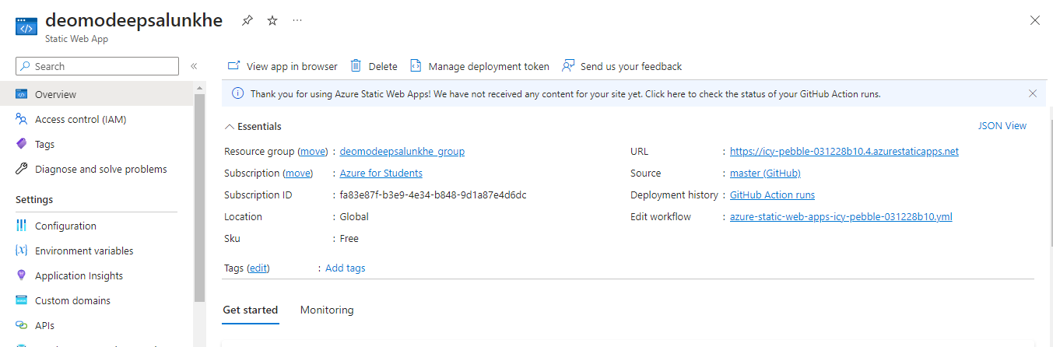

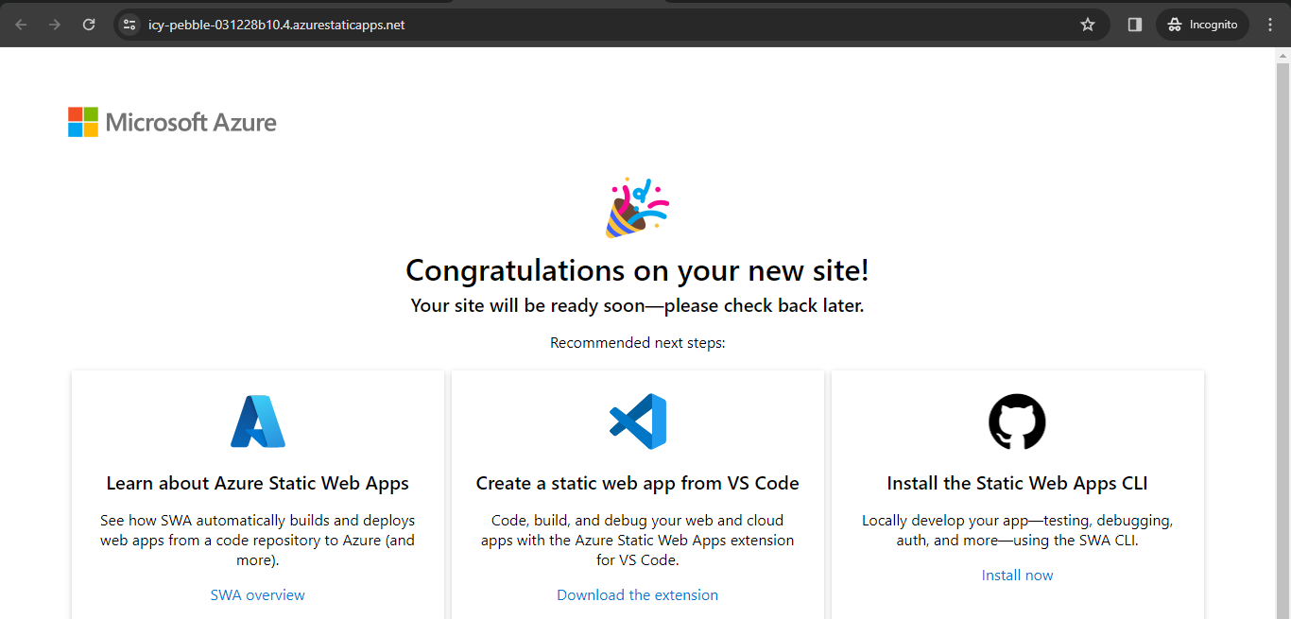

* + **A PHP Web Application**

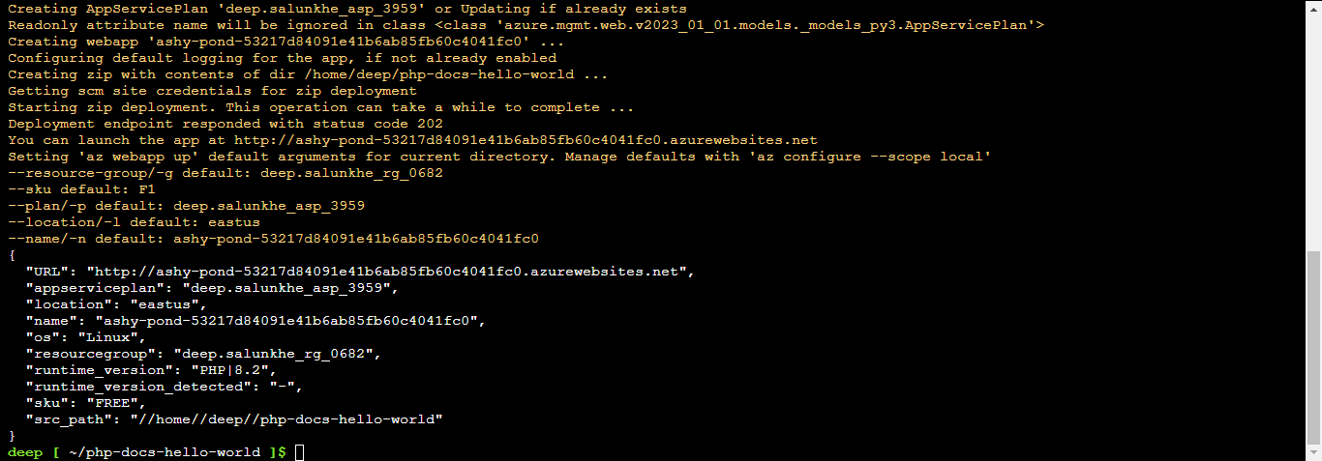

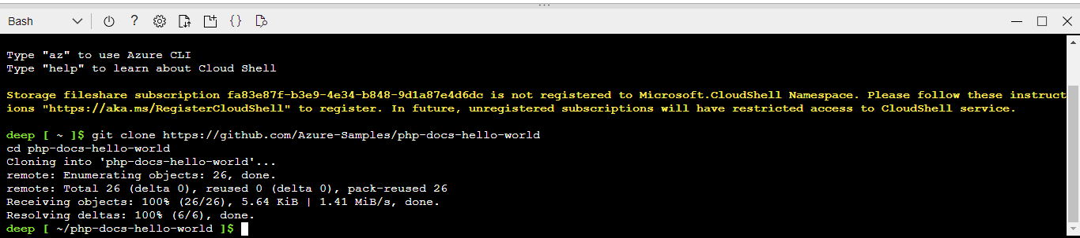

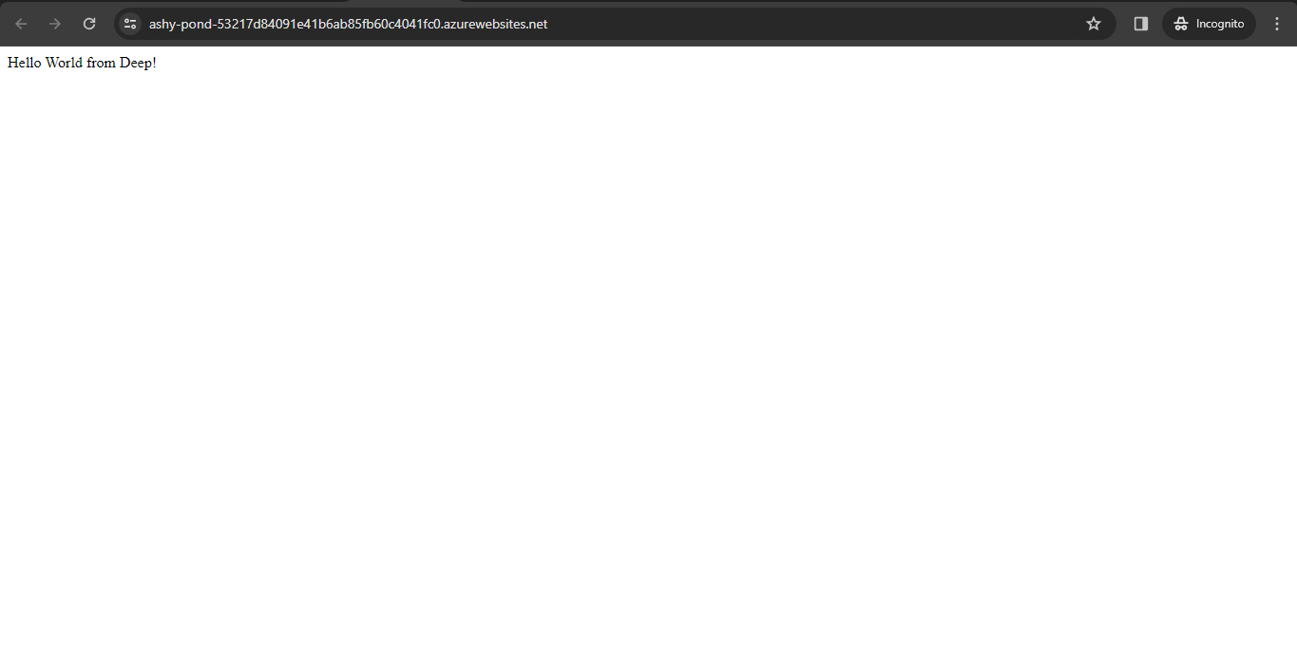

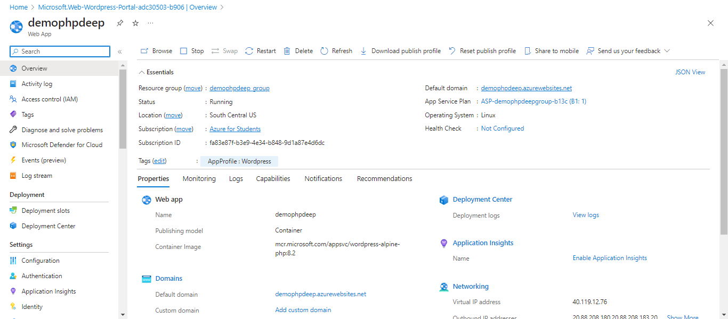

* + **A Wordpress Site**

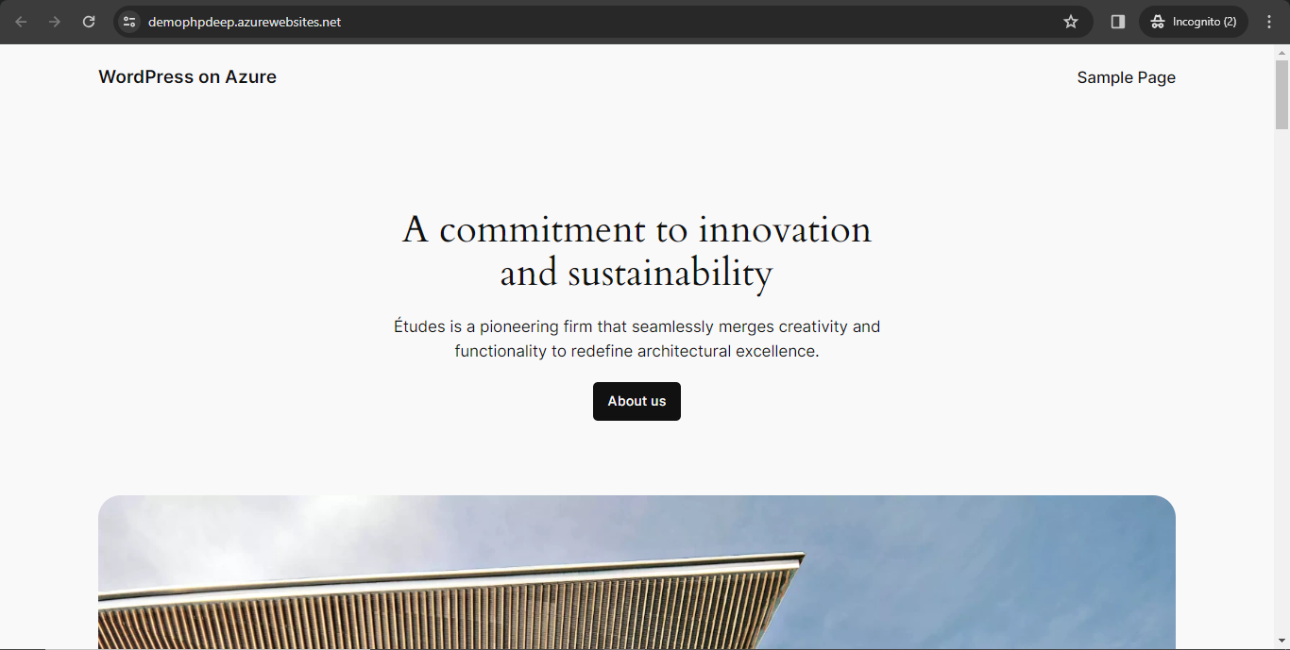

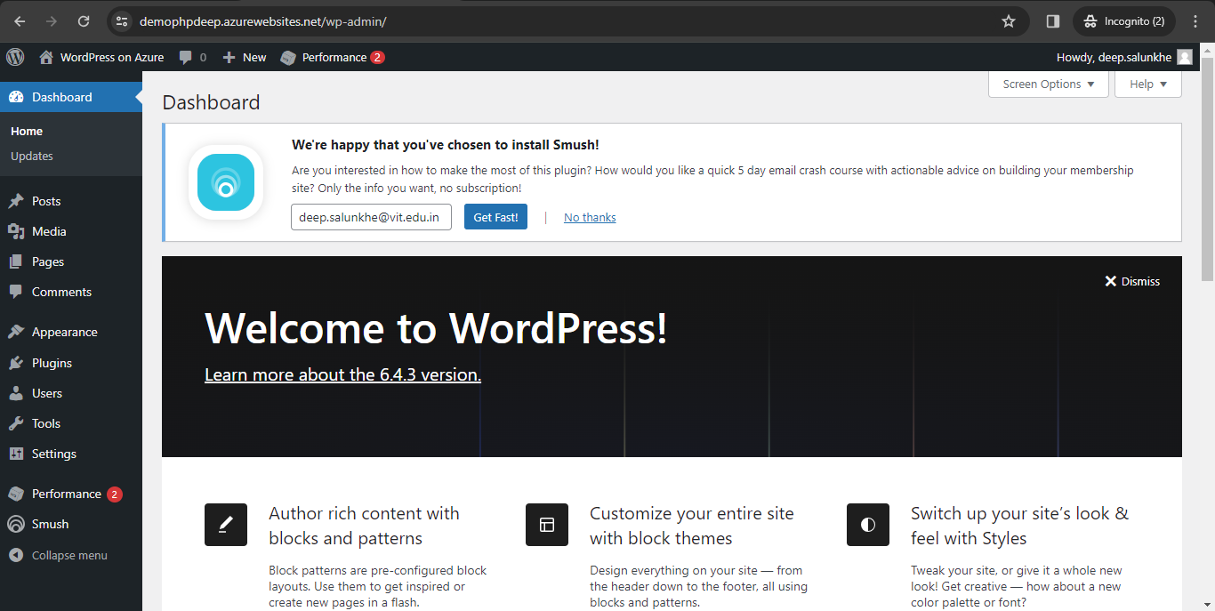

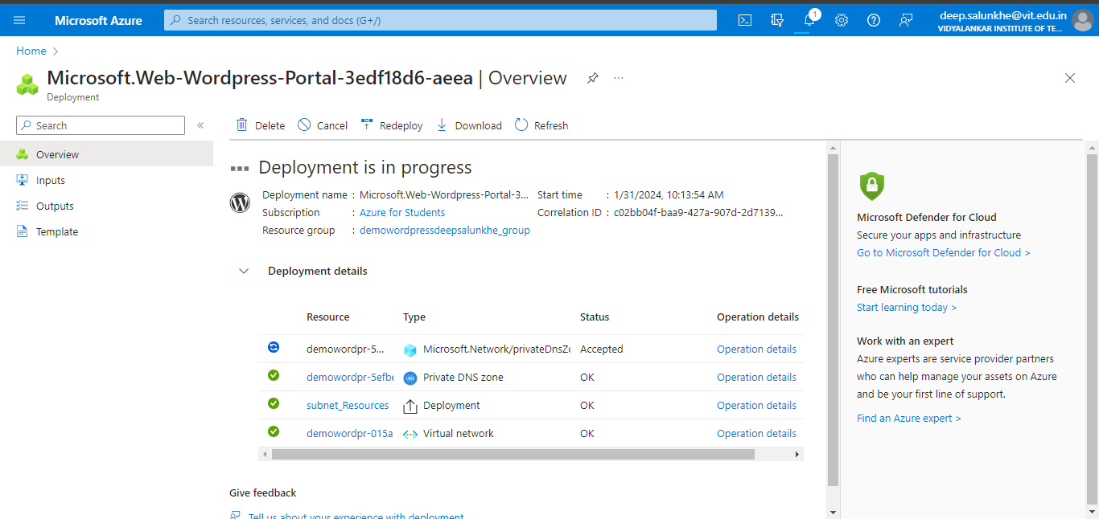

* + **A Node Application**

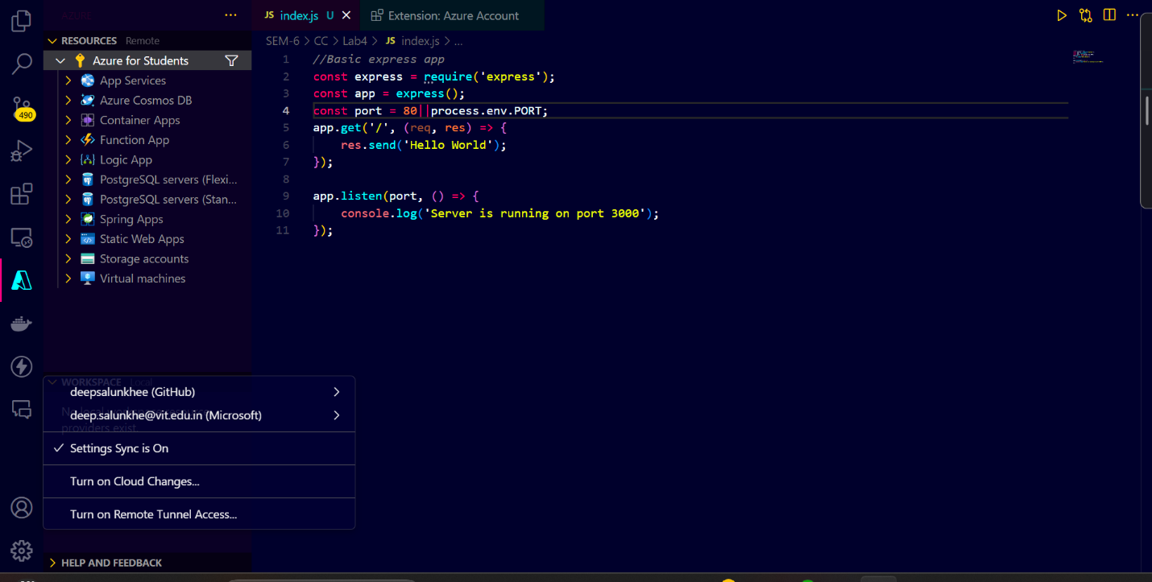

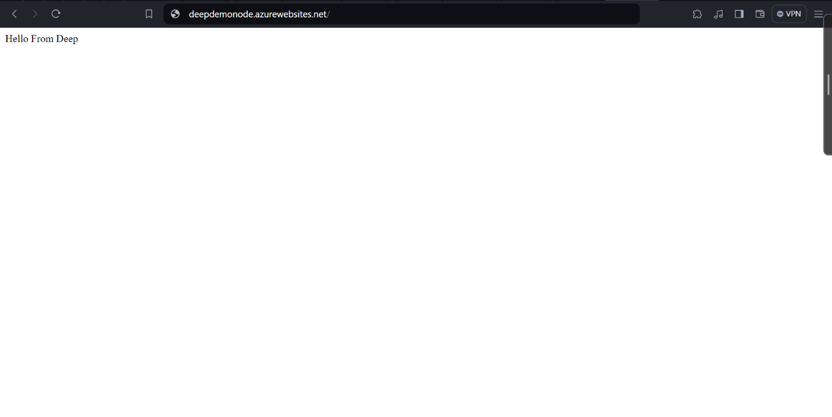

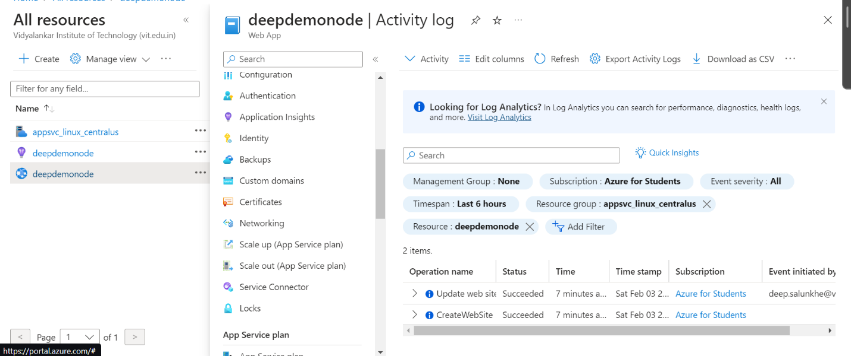



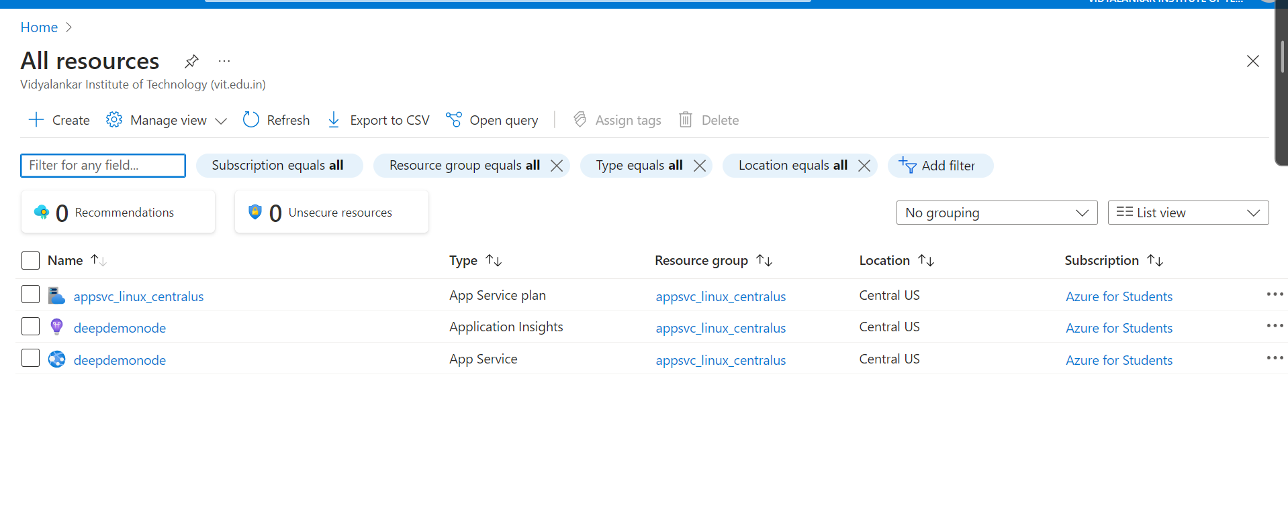

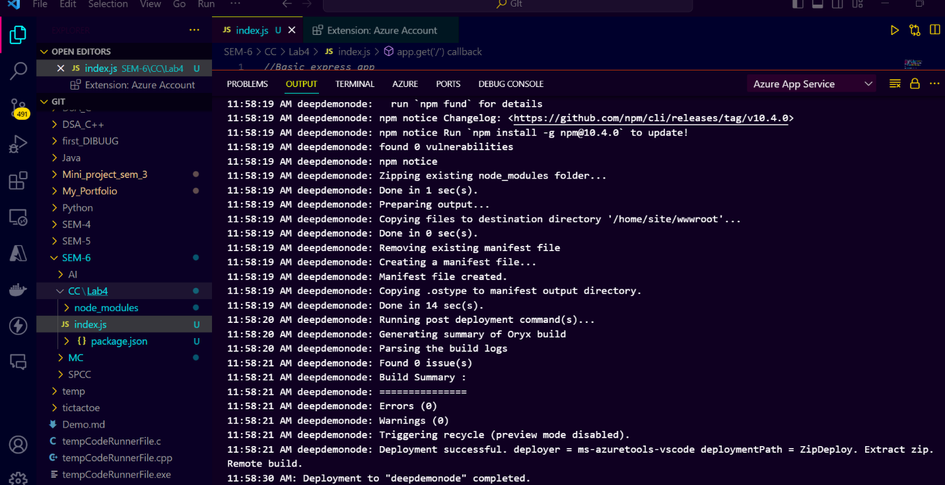

Scenario 2

     -  Using AWS Light Sail

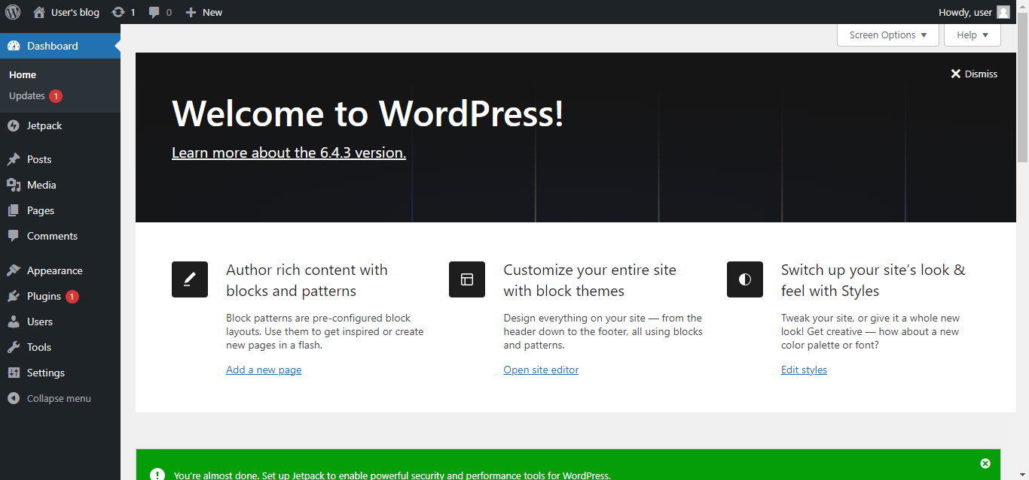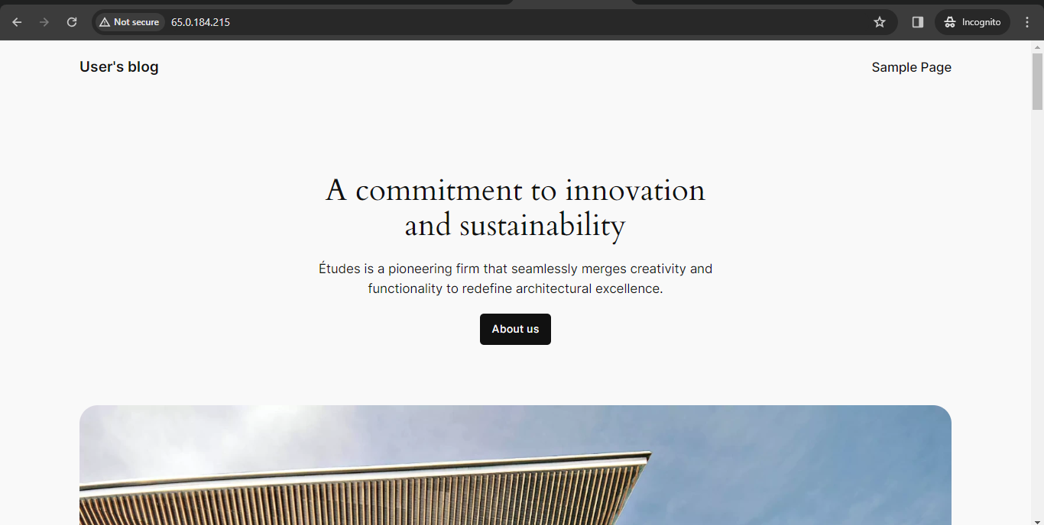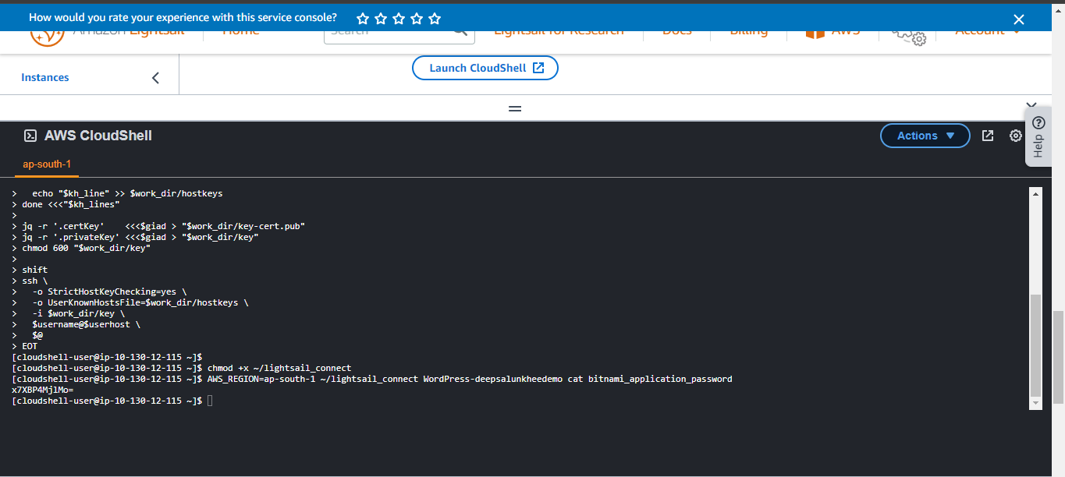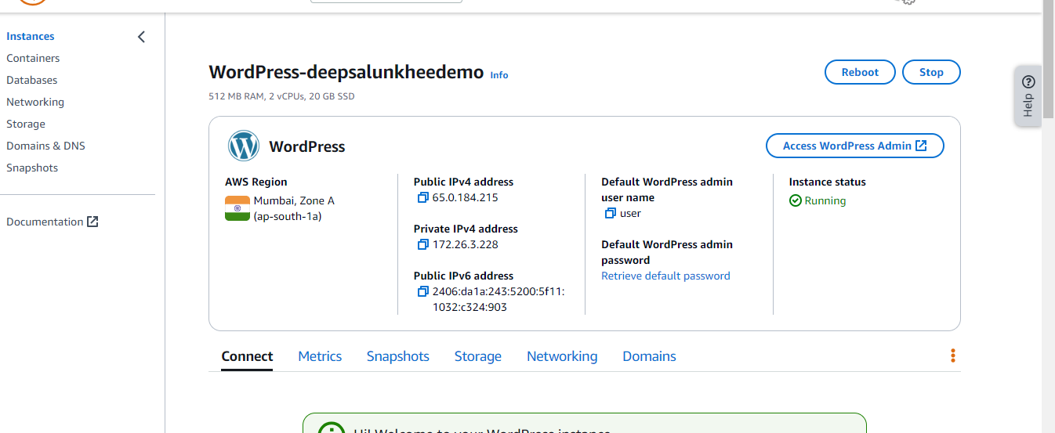

     -  Using AWS  Elastic Beanstalk